CHECKING & SETTING UP USERNAMES AND PASSWORDS (FEDERATIONS ONLY)

HOW TO CHECK/CHANGE A PASSWORD

Click on ‘Utilities’ in the top menu, and then on ‘Security Users’

This will open up the ‘Security User’ Search screen

Here, you can either search for a members username (her email address) or create a new user.

To search for a user, to make sure they have been set up as either an MCS Rep or Federation Rep, you will need to put her email address (or the first part of it) in the ‘Securityuser’ box

If you do not know her email address or you wish to search under something else, you can do, like the name etc.

Then click on Search at the bottom of the page

If the person already has a user set up, they will show up as seen below

Click on the username – (the email address)

This will then take you into the users security profile record.
If you click on the box next to ‘Show Password’ it will reveal the password for that person’s account

If you untick the Show Password box, you can then overwrite it with a new password. You will also need to confirm it in the following password box

Then click on ‘Save’ at either the bottom or top of the page

HOW TO SET UP A NEW USER

When an MCS Rep has the position of MCS Rep assigned to her, she should automatically have a security profile set up for her, and an email is automatically sent to her, informing her of her login details.

If however, you should ever need to set up a user that that has not worked for, you should follow these steps:

Follow the first steps above to get to the main Security Users search screen

You can search for their email address to make sure that they are not already set up. If not, click on ‘Create New’ at the bottom of the page

This will open up the ‘Create New Security User’ screen

Click on ‘Search’, to find the member

This will open up a popup window

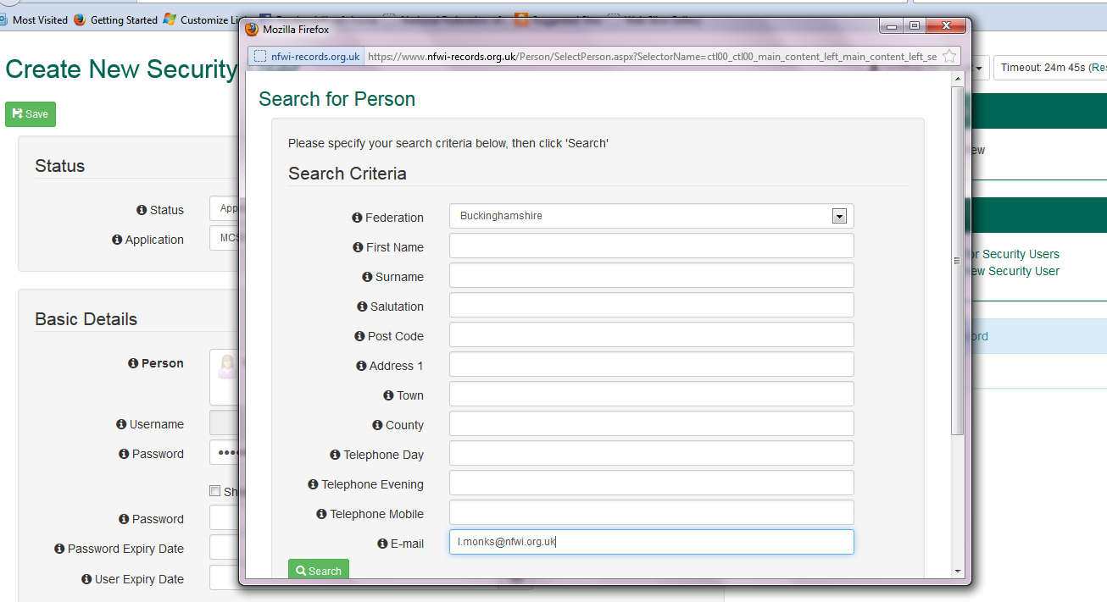

Here you can search using the criteria you want in order to find the member that you wish to make a user

In this case I have used the email address, as above.

Then click on ‘Search’ at the bottom

This will bring up everyone with that specific criteria
If this is the member you want, click on their name (under the Relationship column) to select them

This will then put their details into the main page, where you can enter a password for them (this will appear as dots until you tick the ‘Show password’ box.
You will also need to repeat the password in the password box below it. Then click on ‘Save’.

After you have saved the user, you need to scroll down to ‘Roles’ in order to assign their roles. This is where you can allow/provide them access to their WI or their Federation

For the first example I am assigning a WI MCS Rep for a WI called ‘Test Latel Test’

Click on the Profile dropdown menu, and choose ‘WI: Manager (MCS Rep)’

Your Federation will automatically be selected.
Then select the WI from the WI dropdown menu

Then click on ‘Add Role’

After that you will need to confirm the password again, in the second Password box (you can tick the ‘Show Password’ box to see this)
Then click on ‘Save’ at either the top or bottom of the page.

This is the MCS Rep now set up with access to her WI.

If you wanted to assign a Federation MCS Rep you will repeat as above but when you select the profile from the dropdown menu, you will choose either ‘Federation: Manager’ (this enables them to make amendments to any member in the federation) or ‘Federation: User (read only)’, which does at it says and just gives them Read Only access to the federation’s members

This is the only thing you need to choose. The federation will automatically be selected and you do not need to choose a WI.

Then click on ‘Add Role’, as described above.

When you have clicked on ‘Add Role’, if you scroll down to ‘Security Profiles’, you will see the selections which have been saved

This is showing a WI MCS Rep
This is showing they are the MCS Rep and have full access
This is showing they have WI level access
This is showing the WI they have access to

This is showing a Federation Rep
This is showing they have full access at Manager level
This is showing they have Federation level access
This is showing the Federation they have access to

THINGS TO CHECK

In the event that a user has been blocked from accessing the MCS for any reason:

Search for her ‘Security Profile’ and check to see if it has anything other than ‘Approved’ under the ‘Status’ when you search for her username. If it has anything else, go in and change it to Approved.

You can also change the status from ‘Approved’ to ‘De-Activated’ if you wanted to block someone from accessing the MCS.

If you have any problems assigning a member or finding their ‘Security profile’, make sure that their email address in their members record is correct and double check whether they have been assigned as an ‘MCS Rep’. If both of these are correct they should either automatically be assigned a login with details sent directly to them via email or you should easily be able to find them to assign them a security profile yourself.
PLEASE REMEMBER: You cannot assign someone a security profile (user login) unless they have an email address listed under their member record, or their staff record for a federation staff member.

