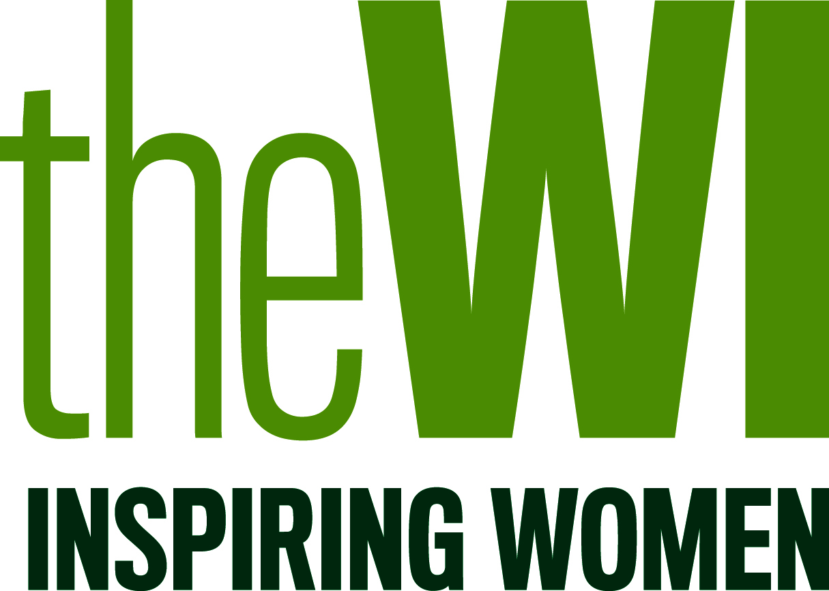How you can take your resolution forward locally

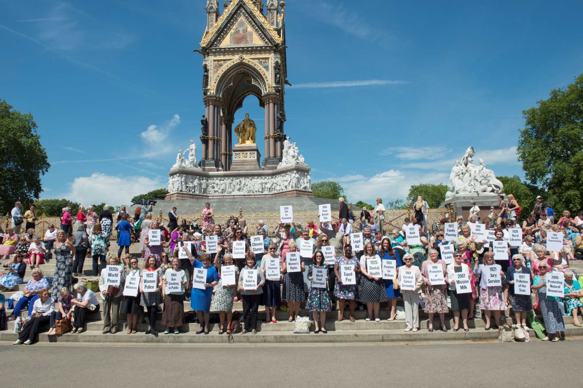The NFWI understands that WIs put a huge amount of work into resolutions, and that it can be disappointing if they are not chosen to go forward.

Here are some ideas about how your WI could keep working on the issue.

Why wasn’t our resolution selected to go forward?

Every year the NFWI receives many resolutions from WIs – 85 in 2016! Federation representatives face the difficult task of shortlisting these down to a few for all members to consider. The box on the right includes the shortlisting criteria.

Shortlisting criteria

* **Topical** – it fits with current areas of public and members’ interest.
* **Timely** – it is not ‘yesterday’s news’.
* **Targeted** – the resolution has a clear and realistic objective.
* **Achievable** – the resolution is calling for something meaningful and sensible that can be achieved.
* **Partnership potential** – the WI’s work will add value to the work of other organisations.
* **Accurate** – it reflects the current situation and does not use outdated or obsolete information as its basis.
* **PR potential** – there is a potential to gain positive media coverage for the WI that could lead to an increase in membership, perhaps by challenging rather than reinforcing media and public stereotypes about the organisation.
* **Appropriate** – it fits with the WI’s charitable objects, history and ethos.

The Public Affairs team are sometimes able to capture feedback from the resolutions shortlisting meeting which could be helpful in considering what to do next with your resolution. The team can also advise whether there are parts of the shortlisting criteria that your resolution did not meet.

Can we submit the resolution again next year?

If your WI feels strongly about an issue then you could decide to resubmit your resolution next year. Before doing this we recommend that you contact the Public Affairs team for feedback about why it was unsuccessful this year, and be prepared to adjust or update it. The team also offers support to help make sure your resolution is well-worded and meets the shortlisting criteria.

How can we work on our resolution as a WI or in our local community?

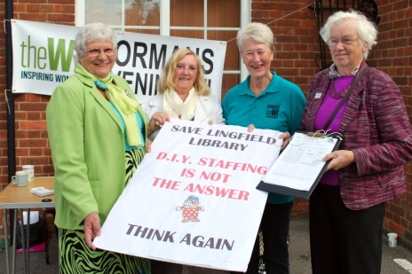As long as your resolution is within the WI’s charitable objects (as stated in the Constitution and Rules for Women’s Institutes), your WI can still work on your resolution in your local community. To check this please contact the Public Affairs Department.

This means that you can set-up and run your own local WI campaign, raise awareness about an issue you feel strongly about, or approach other local organisations to partner with you.

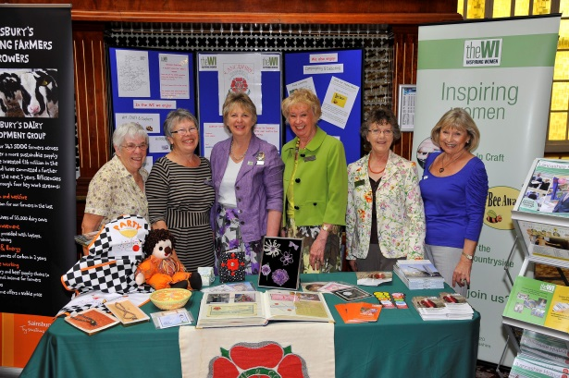You might like to consider the following;

* Holding a discussion event, debate or awareness day in your local community. You could invite expert speakers to attend and provide information materials.
* Starting a petition online or on paper to gather support.
* 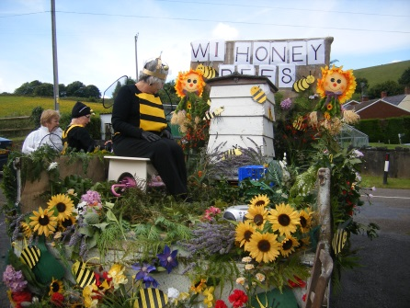Holding a stall for your campaign at a summer fair or fete

How can we work on an issue in our federation?

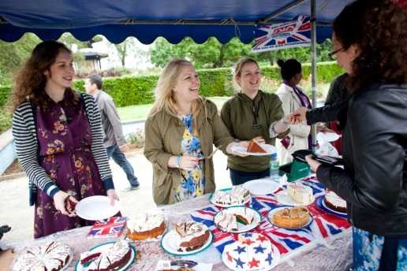Federations can also pass their own resolutions, just like the NFWI. If your WI’s resolution is adopted at federation level WIs from across your local area could campaign on it or even work together on a regional campaign. For example, Norfolk Federation holds an annual event for International Women’s Day and encourages WI members in the area to get involved.

Many national WI mandates have started as federation resolutions, so this could be a good first step in developing your resolution further. Contact your federation to find out how to put your resolution forward – you can find federation details at www.thewi.org.uk

For more information or advice contact the NFWI Public Affairs Department on 020 7371 9300 [pa@nfwi.org.uk](mailto:pa@nfwi.org.uk) or at 104 New Kings Road, London SW6 4LY